**Srilasya Garigipaty**

**DATA 2205**

**Assignment 2: Visualizations**

**Student # 100822953**

**Introduction:** This presentation has been requested by the Ontario Provincial Police to help determine insights into the crime information collected on the two highest crime cities in Ontario, Brantford and ThunderBay. The presentation would be used by the Provincial police to determine how to better work with and support the police force in their efforts to control crime. The presentation will provide insights that compare crime rates, crime incidents, criminal charge counts, and youth and adult crime counts and charges.

**Choice of Visualization Tool:** The visualization tool selected for this presentation is Tableau. Tableau is a data visualization tool that can create dashboards which create actionable insights that drive the business forward. Data was extracted from an excel spreadsheet and combined for the two cities of Brantford and Thunderbay. Tableau was chosen as the visualization tool of choice because the Tableau interface has many visualization options. Tableau can work with large datasets and can be connected to various data sources. Tableau has a stronger data handling capability compared to other data visualization tools,and can answer business question in depth. Visualizations can have subcategories within the business questions that give insights for further research and analysis to other business areas.

**Explanation of Data Analysis/Visualization Approach:** The data analysis approach begins with first loading the data from Statistics Canada at the following link: <http://www.statcan.gc.ca/eng/subjects/crime_and_justice>. The data table [Incident-based crime statistics, by detailed violations, police services in Ontario](https://www150.statcan.gc.ca/t1/tbl1/en/tv.action?pid=3510018001) was used. The data was then narrowed down to 2 municipalities of Thunder Bay and Brantford which are the highest crime cities in Ontario, and the following criteria was selected to analyze on: actual incidents, crime rate per 100000 population, number cleared by charge, cleared otherwise, total persons charged, Rate of total persons charged per 100000 population aged 12 and over, total adults charged, total youth charged, rate of adults charged per 100000 population ages 18 and over, rate of youth charged per 100000 population ages 12 to 17 years. The dashboard visualizations main aim was to answer questions such as what was the crime rates in the two cities in the last five years? Is there a correlation between youth crime and adult crime for each crime rate city? Which city had the most crime activity? Were the number of people being clearing showing any trends to adults charged or youth charged? Which city had the most adults charged? Which city had the most youth charged? Visualizations such as bar graphs, line graphs, scatter plots, packed bubble charts, and butterfly graphs were used to answer these questions.

**Data Visualizations:** The first dashboard represents an analysis of Youth and Adult crime in Brantford and Thunderbay. The second dashboard represents an analysis of total crime and depicts total crime rate per 100000 population for both Brantford and Thunderbay, and the total number of actual crime incidents in both Brantford and Thunderbay on a yearly basis.

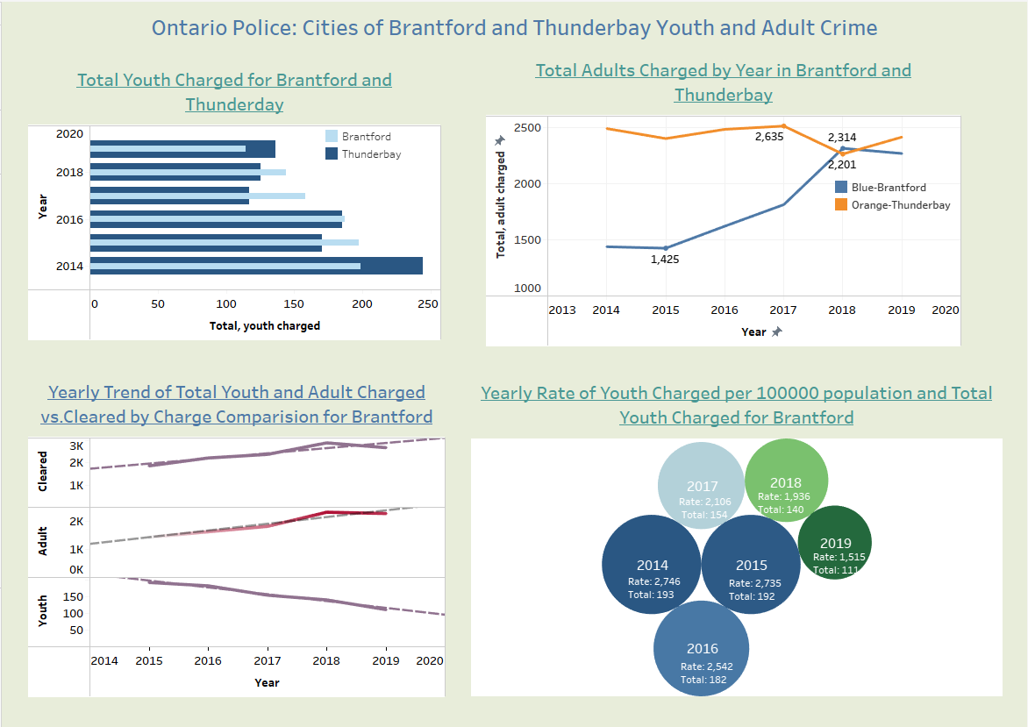

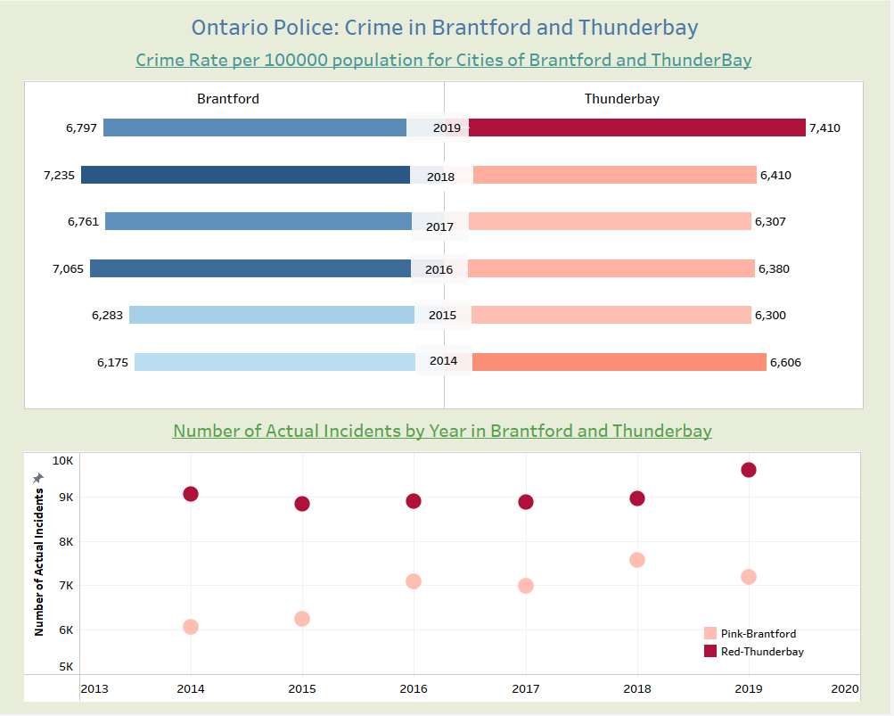

**Crime Rate Prediction:** It can be noted from the first dashboard that youth and adult crime rates have decreased in both Thunderbay and Brantford in the last three years from 2017. The adults charged has been increasing in Brantford in the last 5 years though 2018 has seen a steady decrease. The youth charged in Brantford has been on a decline as seen by 2018 and 2019 numbers. The adults charged in Thunderbay has been decreasing in the last 5 years, though 2018 has seen some steady increase. Despite the increases, the number of youth and adults charged has shown a positive trend in the last 5 years. The crime rate per 100000 population has decreased in Brantford from 2018 to 2019 but increased in Thunderbay from 2018 to 2019. Thunderbay has had more crime incidents in the last five years compared to Brantford. For the next few years, the predicted crime rate may decrease in Brantford and increase in Thunderbay given the currents trends. There will be more Adults than youth getting charged in Thunderbay, and a decline in youth and adult charges compared to previous years in Brantford. Being the two highest crime cities in Ontario, Officer Richardson should look to utilize the Ontario Police resources to prevent crime in Thunderbay and Brantford and utilize operating resources towards high crime areas in Thunderbay and Brantford where majority of youth and adult crime occur.